## Dataset

Dataset chosen for this assignment is called “Data on COVID-19 vaccination in EU/EEA (European Centre for Disease Prevention and Control, 2021), and was obtained from the European Centre for Disease Prevention and Control website.

Initially, it contained 815,597 rows and 18 columns.

## N.A values and repetitive columns

In the first step of cleaning data, I identified that one of the columns, called “FirstDoseRefused” contained only “N.A” values. We have to remove this column in order to proceed with any further exploration.

Further filtration with na.omit() function has not change dimensions of the dataset

Upon further investigation of the original dataset we can conclude that two of the columns have very similar values. Those columns are Reporting Country and Region. We can identify that there are 22 reporting countries and 24 regions, and from the PDF documentation included with the dataset, we can find that regions are specific to the country. Therefor, we can remove region column from the dataset

Dataset dimensions after cleaning of NA values:

* Number of rows: 85140
* Number of columns: 16

## Identification of variable types and description

**Categorical**:

* YearWeekISO - year and week reported
* ReportingCountry - country code
* Target Group - age group
* Vaccine - vaccine code

**Discrete Variables**:

* Denominator
* Number of Doses Received
* Number of Doses Exported
* First Dose
* Second Dose
* Dose Additional 1
* Dose Additional 2
* Dose Additional 3
* Dose Additional 4
* Dose Additional 5
* Unknown Dose

**Continuous Variables**:

* Population

## 

## Outliers

In terms of outliers, we can identify 2 different columns in which outliers could occur, such that it could influence our later exploration. Those columns are Denominator (fig 1) and Population (fig 2).

We can further read from the PDF document obtained along with a dataset from the website (European Centre for Disease Prevention and Control, 2021) that Denominator is *“Population denominators for target groups (total population and age- specific population obtained from Eurostat/UN). Denominators reported by countries for TargetGroup = “HCW” and TargetGroup = “LTCF”.”* and Population is “*Age-specific population for the country*”.

In terms of those 2 variables, outliers would indicate that the population in a particular country is larger than the average, however, this would not change further observations since the number of vaccines received should be corresponding to population number.

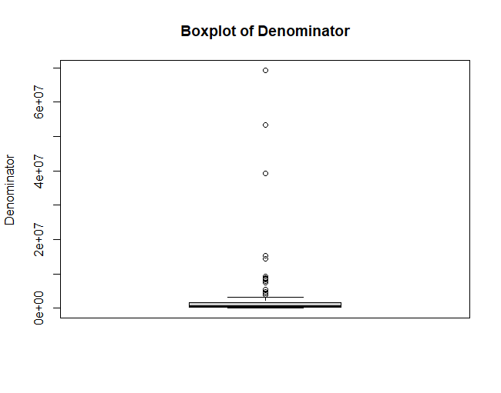

*Fig 1 - Box plot of Denominator*

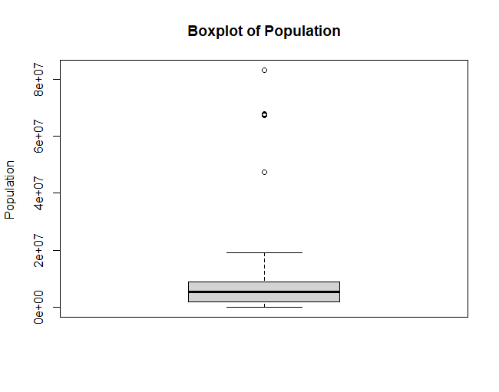

*Fig 2 - Box plot of Population*

## 

## Statistical Parameters

| **Column Name** | **Minimum** | **Median** | **Max** | **Mean** | **Standard Deviation** |
| --- | --- | --- | --- | --- | --- |
| Denominator | 313 | 503217 | 69373865 | 2297011 | 7229396 |
| Number of Doses Received | 0 | 0 | 13092598 | 9498 | 153786.5 |
| Number of Doses Exported | 0 | 0 | 6488820 | 1052 | 153786.5 |
| First Dose | 0 | 0 | 4021725 | 2278 | 47468.14 |
| Second Dose | 0 | 0 | 4149209 | 2175 | 46673.87 |
| Dose Additional 1 | 0 | 0 | 6647843 | 1932 | 55879.54 |
| Dose Additional 2 | 0 | 0 | 598894.0 | 528.2 | 9542.449 |
| Dose Additional 3 | 0 | 0 | 337594.0 | 122.3 | 3570.396 |
| Dose Additional 4 | 0 | 0 | 34714.0 | 7.2 | 301.7767 |
| Dose Additional 4 | 0 | 0 | 30509.000 | 2.228 | 189.5138 |
| Unknown Dose | 0 | 0 | 22367.000 | 5.238 | 204.3932 |

As we can see that standard deviation is mostly a large number which indicates that data is spread out. Standard deviation is larger than mean, therefore the majority of values lay in the higher range.

## 

## EDA

### 

We can find 22 distinct countries reporting in this dataset. Since this dataset is obtained from the EU, it only includes European countries. We can display the distribution of population across this dataset with histogram where Population is on x axis and frequency of given population occurring on y axis. (Fig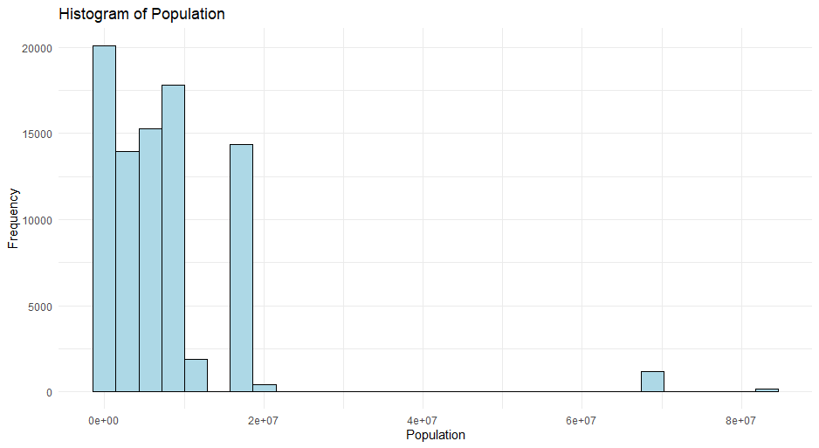

*Fig 3 - Histogram of population*

Each country reports every week. And since their population does not change significantly within a short period of time, we get consistent values of population across observations from distinct countries. We can also conclude that the majority of reporting countries' population falls under 20 million people.

Another observation that we can make is total a total number of different vaccine types by country reporting (Fig 4)

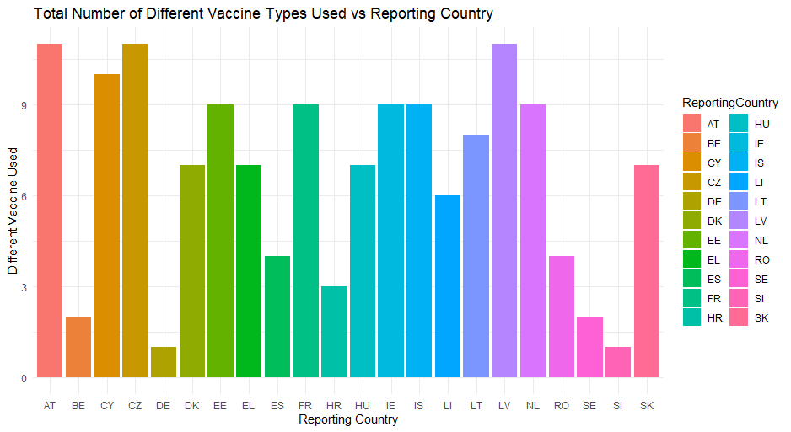

*Fig 4 - Number of different vaccine types by country*

We can also derive the population of each reporting country (Fig 5).

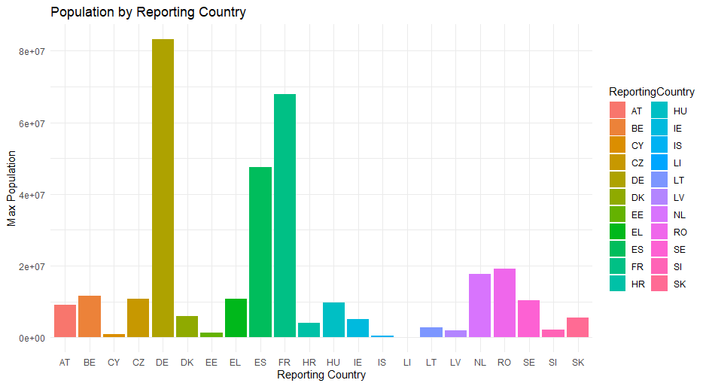

*Fig 5 - Population by reporting country*

### 

### Correlation between numerical variables

We can show correlation between numerical variables in the dataset by creating a heat map (fig 6). We can observe that, there is correlation between first and second dose, however, in general correlation between variables is weak. The correlation between NumberDosesReceived, FirstDose and SecondDose indicates that reporting countries were able to administer more first and second doses as they receiving number increased.

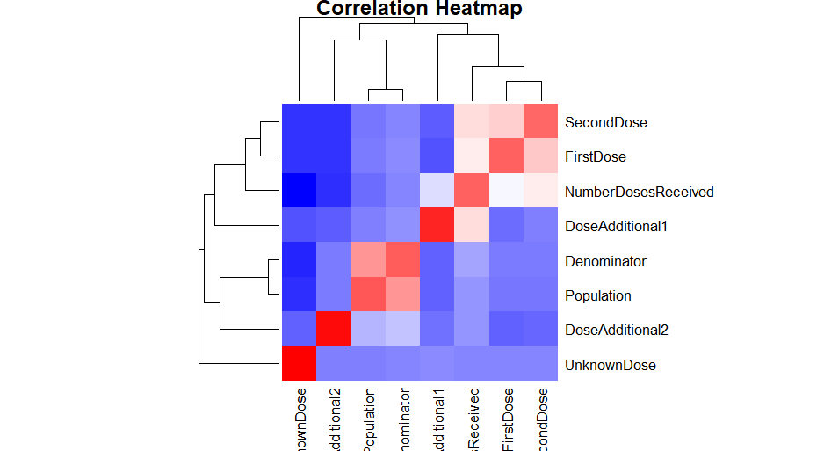

### *Fig 6 - Heat map between numerical variables in dataset*

### Observations

We can calculate and observe the total number of doses administered by the target group, which in our case is an age group.

In order to achieve it, we need to create additional columns in each observation, sum up values from columns: FirstDose, SecondDose, AdditionalDose 1- 5, and assign it as Total Dose. This will represent the total dose administered by TargetGroup in a given week.

Then, we need to create a table of groups and total doses administered. We need to remove several target groups such as All, AgeUNK, HCQ,LTCF,AGE<18. After cleaning the table, we can create a barchart. (Fig 6)

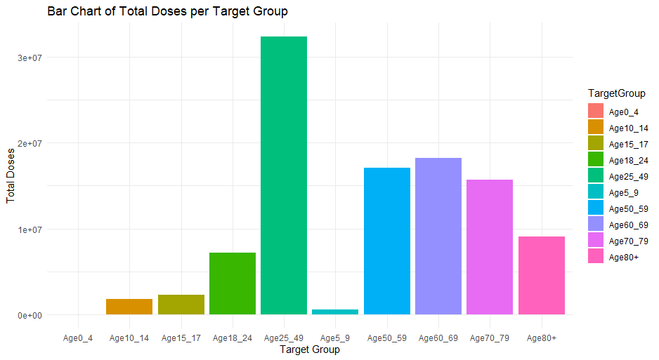

*Fig 7 - Total Doses Administered by Target Group*

Another interesting observation is the distribution of vaccine types across dataset (Fig 8).

We can observe that the biggest 4 vaccines administered to the population were AZ (AstraZeneca), COM (Pfizer/BioNTech), MOD(Moderna), JANSS (Janssen).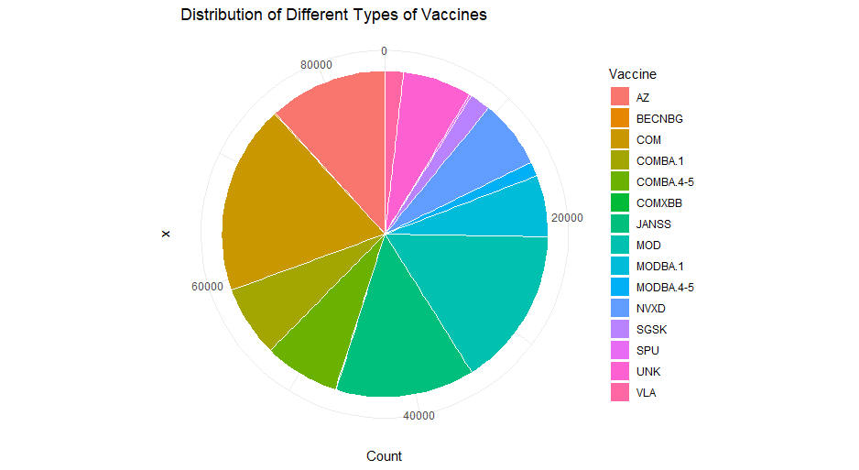

*Fig 8 - Distribution of vaccine type*

## 

## Dummy and One-hot Encoding

In my opinion there are 3 categorical variables that are candidates for one-hot encoding. We can choose Vaccine, Target Group or Country Reporting as a target variable for encoding. I decided to hot-one encode Vaccine. Ideal variable would have only two categories, then we could assign binary encoding, either true (1) or false(0) value. However in the case of this dataset, each of the variables have many different categories, in the case of the Reporting Country is 24, Vaccine is 16 and Target Group is 15.

As a consequence of one-hot encoding, we will add 16 columns to our dataset.

EXPLAIN BENEFITS

## PCA

As we can deduct from the heat map previously presented (Fig 6), there is little correlation between variables in this dataset. The only variables that show correlation are DosesReceivede, FirstDose and SecondDose. I decided to use those three variables as targets for PCA analysis.

For this PCA analysis I decided to use the FactoMineR library.

The result of PCA performed in R are:

* Dim.1 - variance: 2.32, % of variance: 77, cumulative % of variance: 77
* Dim.2 - variance: 0.3, % of variance: 13, cumulative % of variance: 90
* Dim.3 - variance: 0.2, % of variance: 9, cumulative % of variance: 100

We can observe that with Dim.1 and Dim.2 combined together have over 90% of data, and those are to components with the largest relative importance (Fig 9)

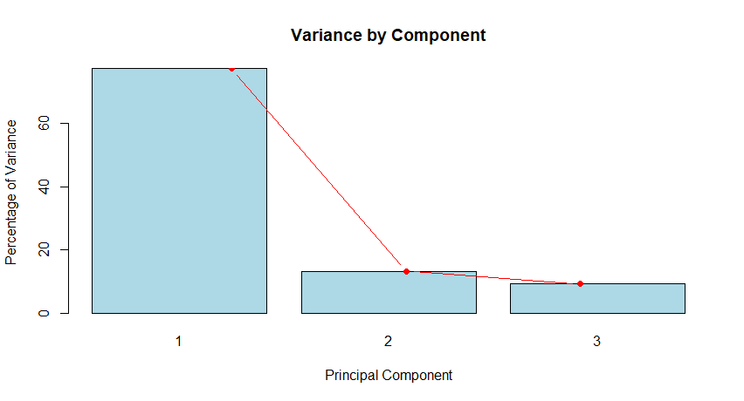

*Fig 9 - Relative importance of each component*

We can further observe and graph correlation between each variable in those to results (Fig 10).

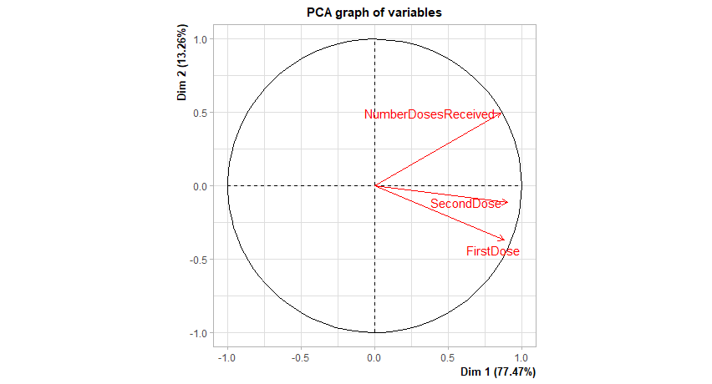

*Fig 10 - Correlation between variables in PCA*

We can observe that all variables exhibit positive correlation among each other, however, the graph indicates that correlation between First and Second dose is stronger than other correlations. This graph exhibits 90% of data.

Upon further investigation, I found that if we increase the number of columns to include AdditionalDose 1 - 5, the correlation positive among initial 3 variables seems to be even higher. (Fig 11) This might be due to the fact we operate with much more data, and proportion has changed.

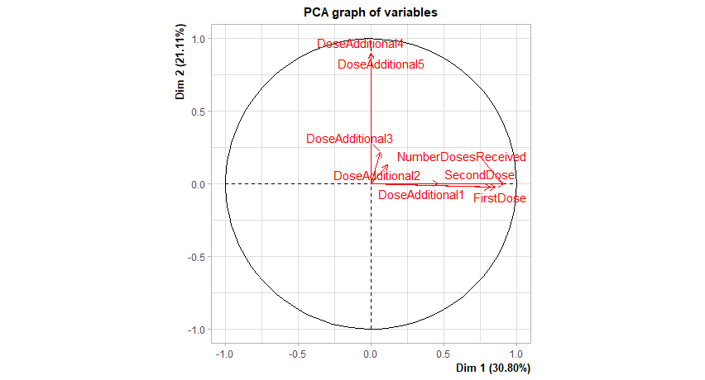

*Fig 11 - Correlation with more variables.*

Additionally, we can observe strong positive correlation between Dose Additional 1 and Dose Additional 2, Dose Additional 3,4 and 5 do not exhibit strong correlation.

Unfortunately, the factor map graph for this dataset does not provide meaningful visualisation due to the large number of observations in the dataset.

## Conclusions

This dataset included a vast amount of information. It includes information on vaccination from 24 European countries. It is ordered chronologically by ISO timestamp, and this resulted in certain variables having values only in the last quadrant. For example, additional doses 4 and 5 would be administered to the population after most of the population was given the first and second dose.

We also observed which vaccines were the most popular and which age group was vaccinated the most.

Finally, we have seen correlation between the number of variables, and concluded that the first and second dose and number of doses received show positive correlation.